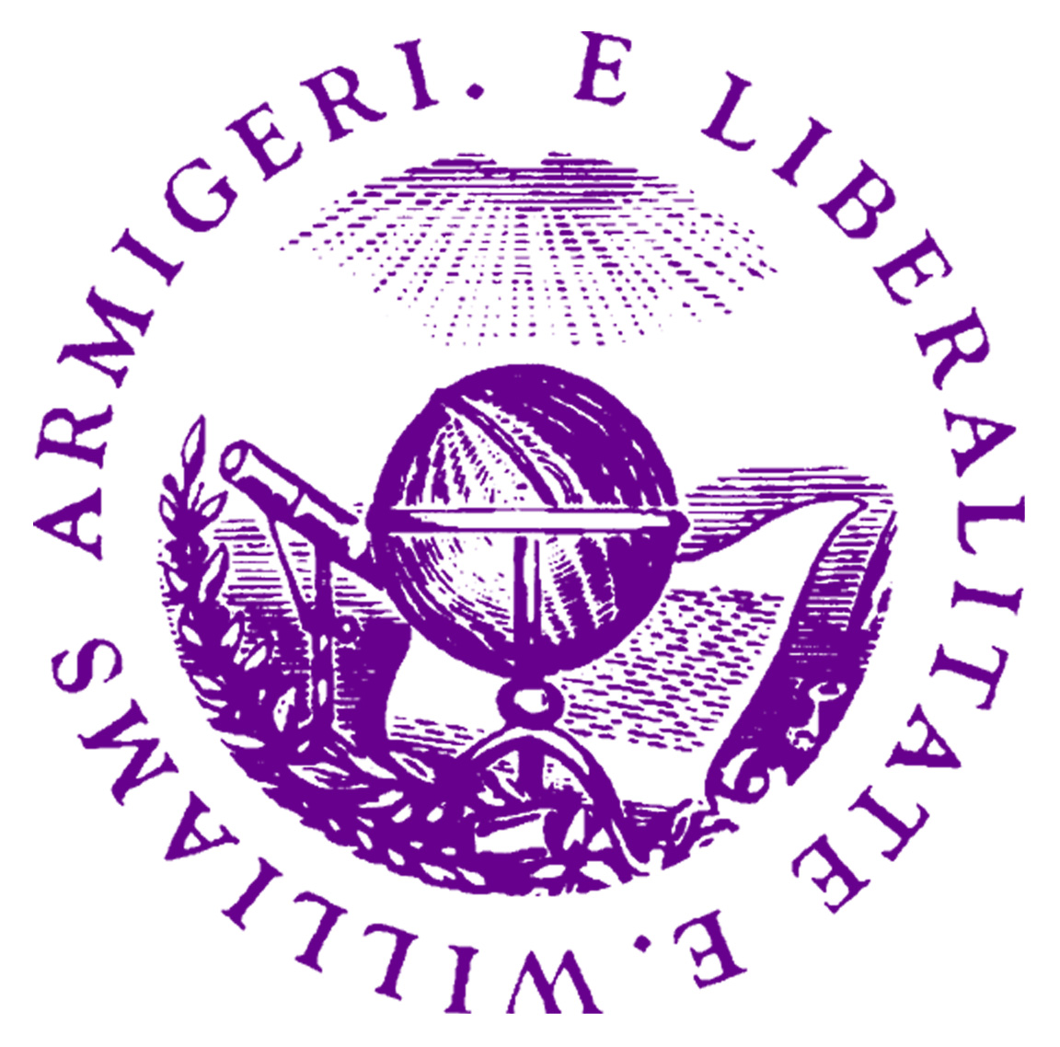
Application Form: Personal Statement

MA in Policy Economics

Williams College
August 2023 – June 2024

Please submit by December 1, 2022

Surname: _____________________________ Given names: ___________________________________

Male ___ Female ___ Date of birth: Month: _____ Day: _____ Year: _____

Country of citizenship: ____________________________________________________

Primary email: ____________________________ Secondary email: ____________________________

Personal Statement:
Please write a brief personal statement regarding your future career plans (no more than 200 words, please use complete sentences).

